Accessing the 7th Grade Math Book & Tutorials Online (this will allow me to try the f flipped classroom as I will have the students view an online video.

- Enter http://my.hrw.com from any web browser
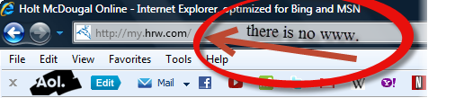

- Enter the user name and password. If you are in 2nd period the user name would be mcgee2 and the password would be period2 The number represents which class period the student is in.
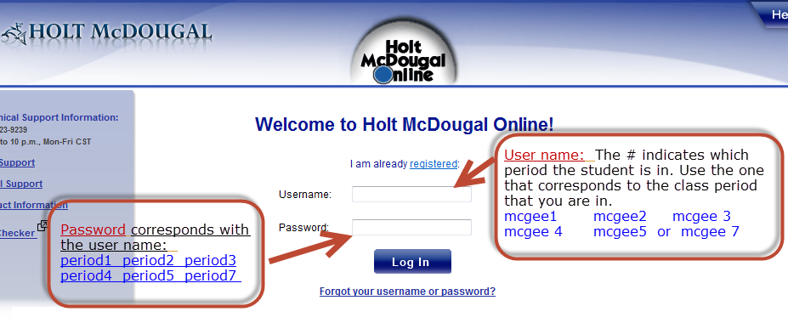
- Use the drop down box to select the desired chapter
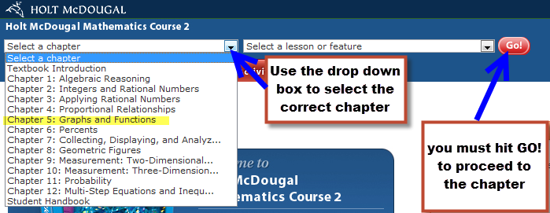
4. Select the Videos & Activities red tab at the top.
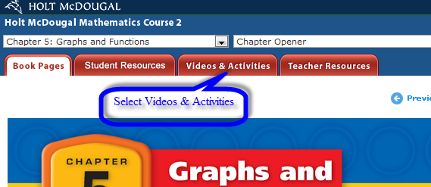

- Select the Lesson Tutorial Videos tab. Then view the specified examples. Some lessons will have more examples than others.
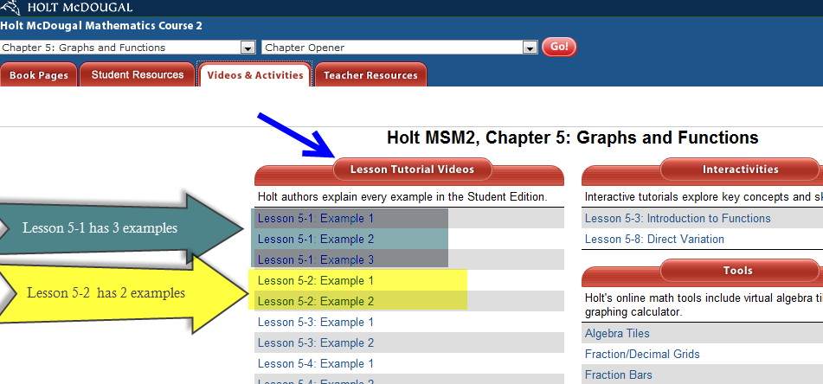

- Once a lesson is selected, a video with Professor Burger will begin to play there will be a lesson with both audio and visual presentation. Please take notes and list any questions you may still have. You may pause the video or replay it at any time.
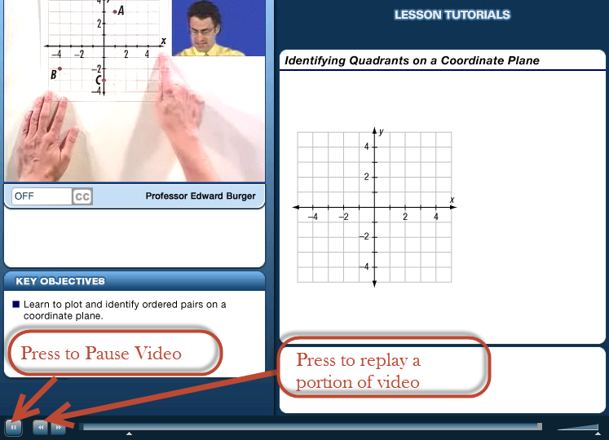

- Once the tutorial is complete, the video goes black. Close out the video by selecting the ‘X’ in the upper right hand corner.
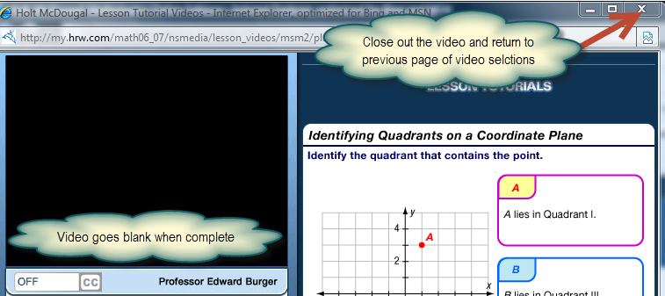

- You will now be returned back to the Video & Activities of Chapter 5, here you can select the next video example. Once complete you may select the logout button in the top right hand corner.
